NESHAMINY HIGH SCHOOL

Athletic Department

**Part 2 - Impact Test Administration Instructions**

**To ensure a valid test, please follow all instructions. It is very important that you are able to fully concentrate during the entire test. Poor performance will in an invalid test and will require a retake!**

* Set aside 30-45 minutes in a quiet room with no distractions to take the test
* No headphones or cell phone use during the test
* Turn off any televisions, radios or anything else that can produce background noise
* We recommend taking the Baseline Test on your Chromebook

**Starting the Baseline Test:**

* Go to: [www.impacttestonline.com/schools](http://www.impacttestonline.com/schools)

• Enter Customer ID code: 4d95063ad7

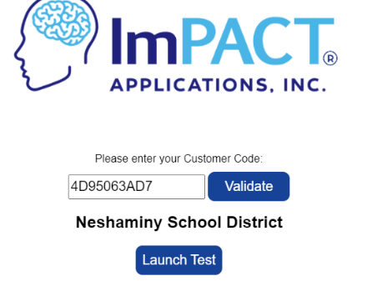

* Select Launch Test and follow prompts.
* When the below prompt appears select the bottom choice**, Enter Additional Demographics**:
  + Enter your school email when prompted to enter an email.

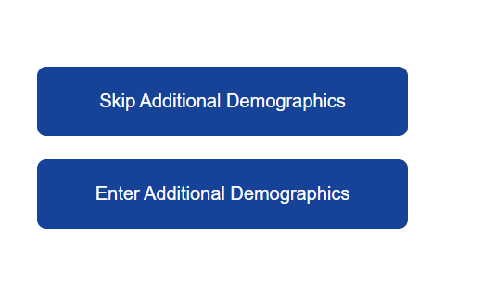

* Once you are done entering all of your demographic information, you will begin the test.
* There are 6 sections call “modules.” These include word memory, design memory, x’s and o’s, symbol match, color word match and three letters
* Take your time to read each section’s instructions very carefully. Each module is self-explanatory
* Your test results are not displayed when you are finished, they will be sent to Justin Lewis, our athletic trainer.
* When you are finished you should just close the program, and this will send the results to Justin.
* Any questions, reach out to Justin (jlewis@neshaminy.org).